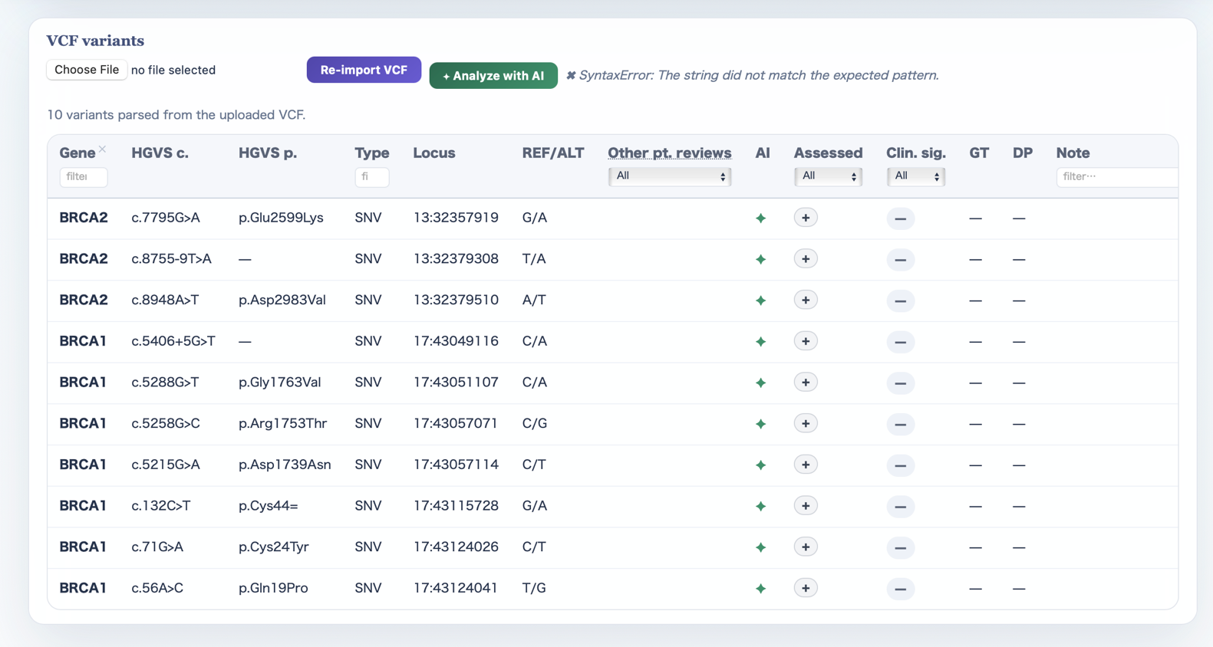

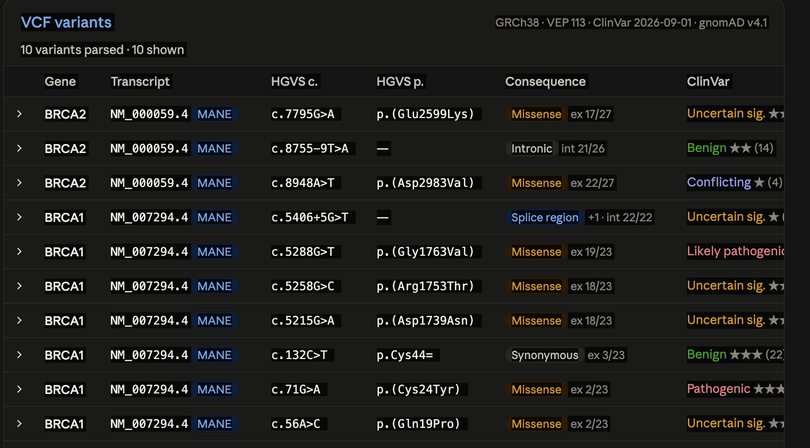
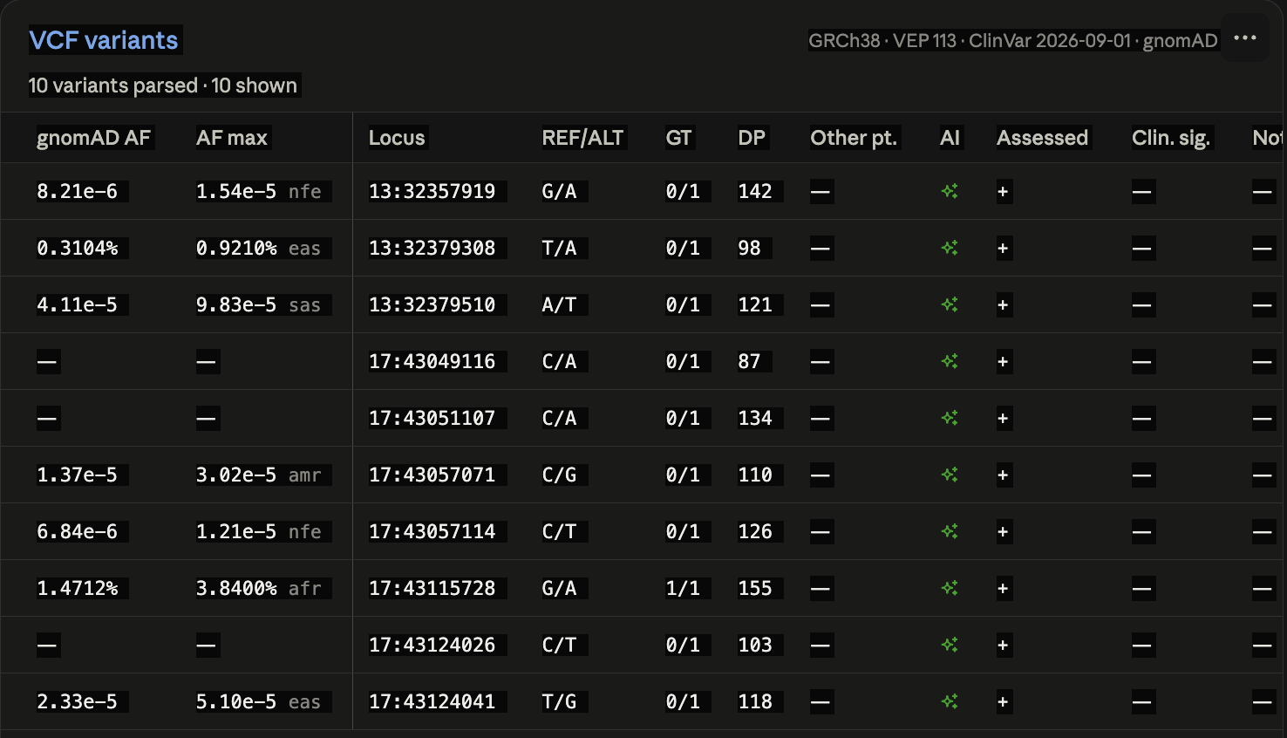
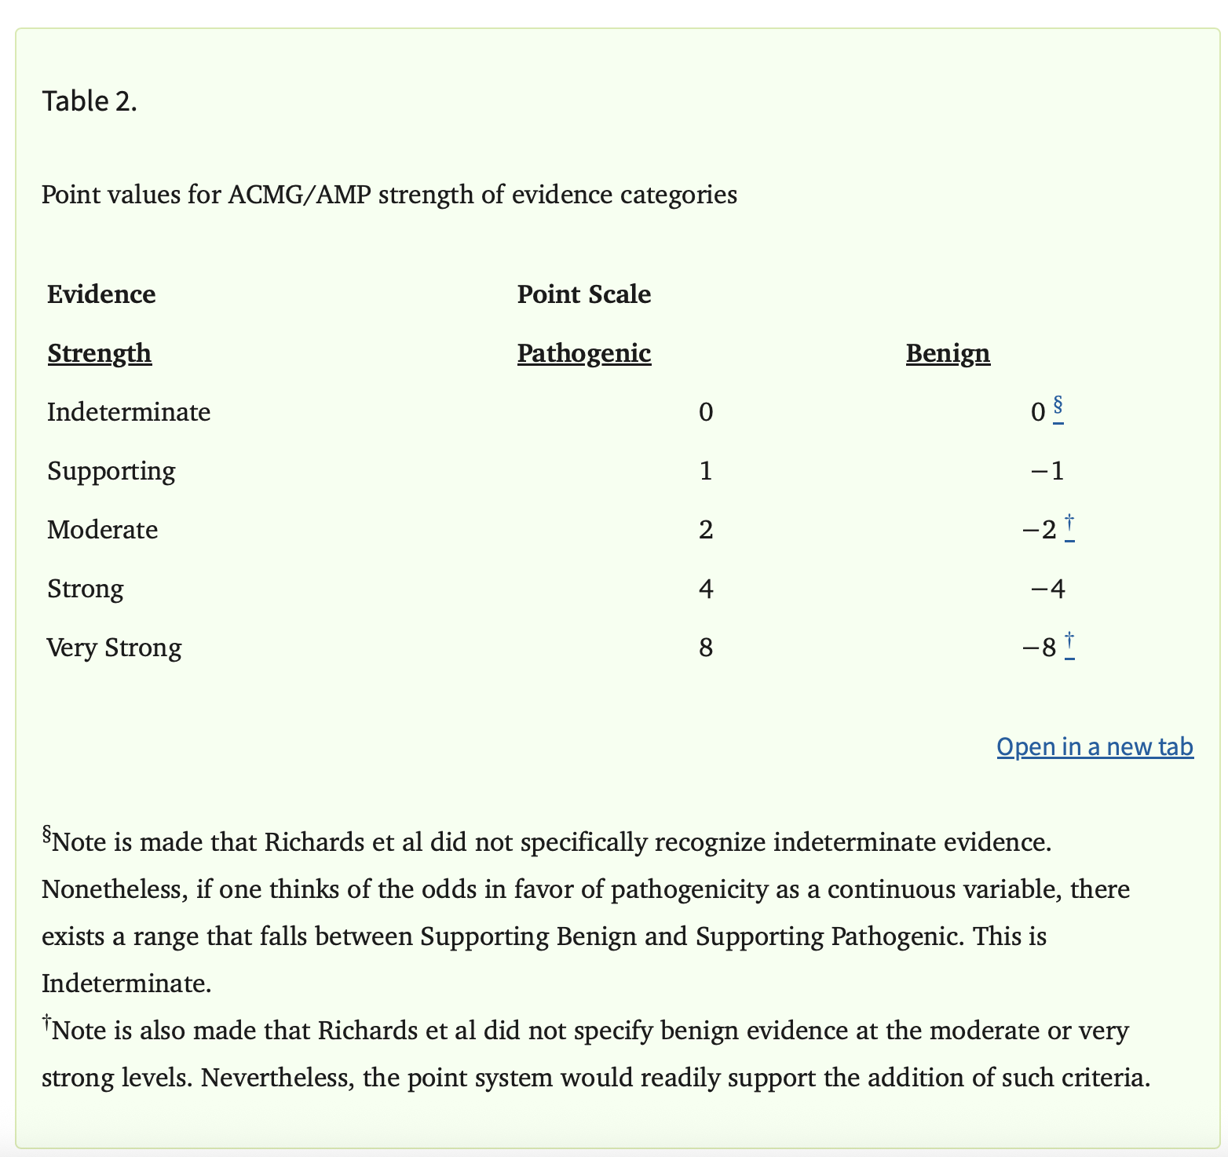
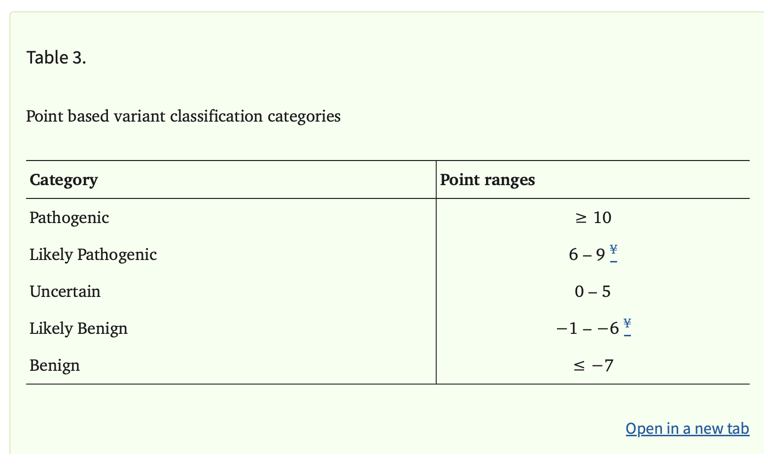

For each code, allow to add free text for evidence
PVS1:
Add autoPVS1 chart data/ result
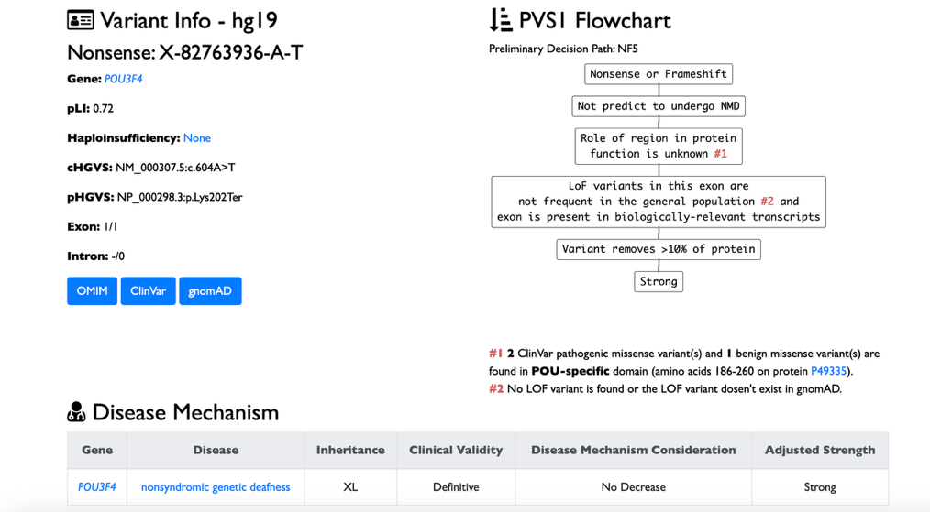
https://autopvs1.bgi.com

PS1:
show the clinvar page/ summary for that codon
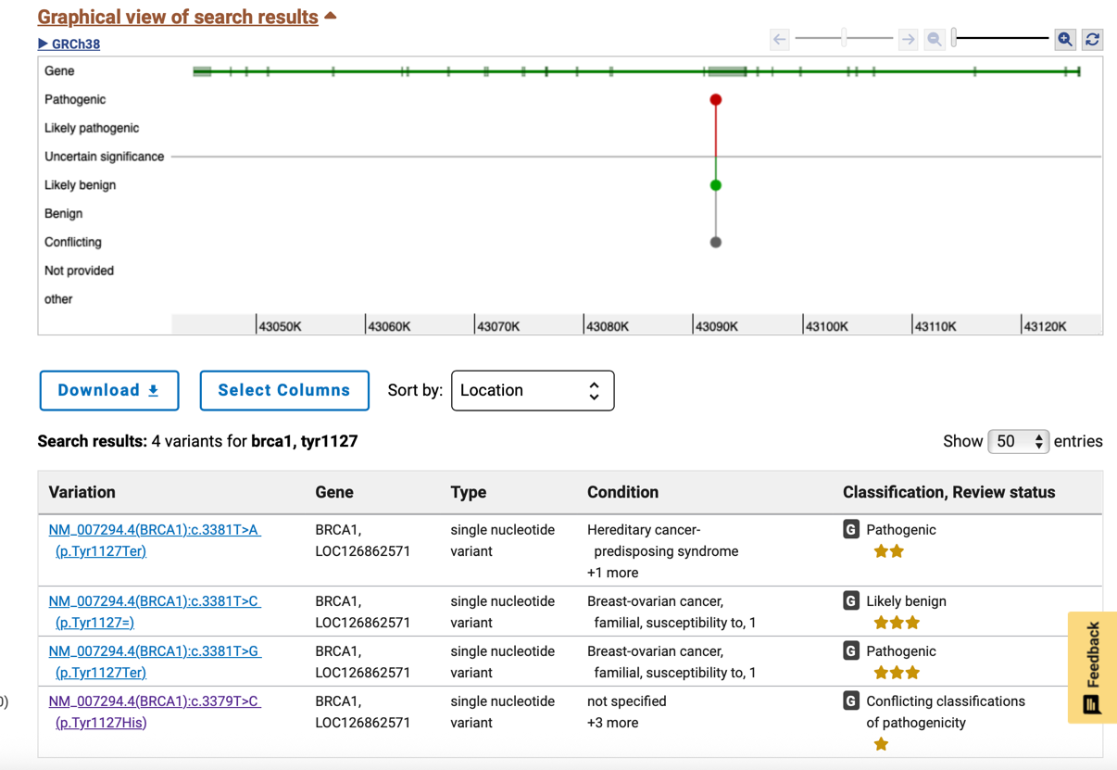
PM1 and PM5:
Can show variant location/ domain, and can use AI to check if hotspot/ any nearby benign variants.
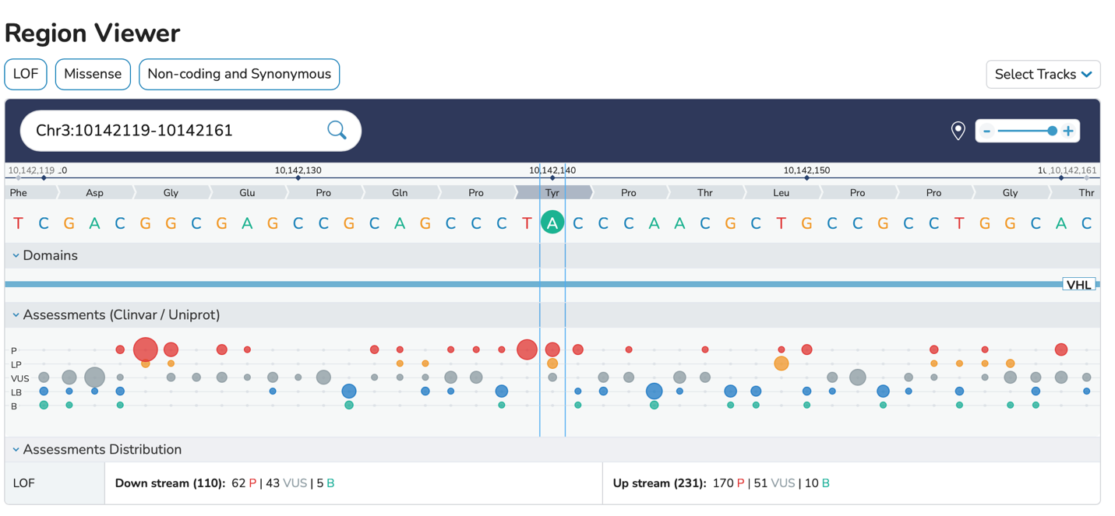

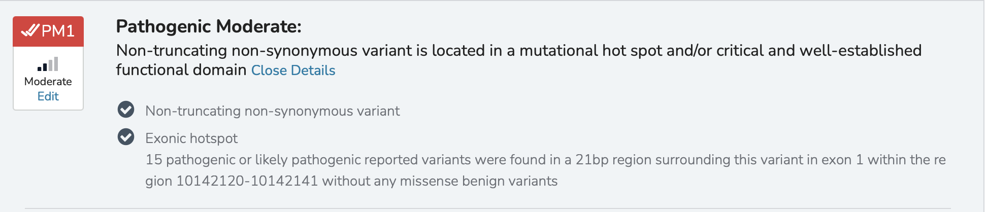

PM2, BA1, BS1, BS2
Show the gnomAD af page
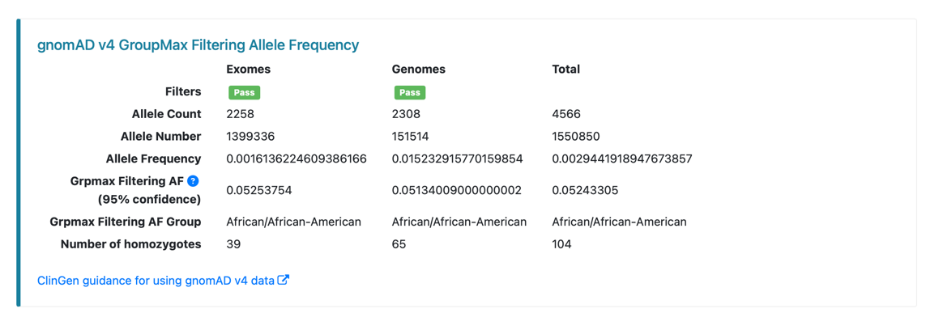
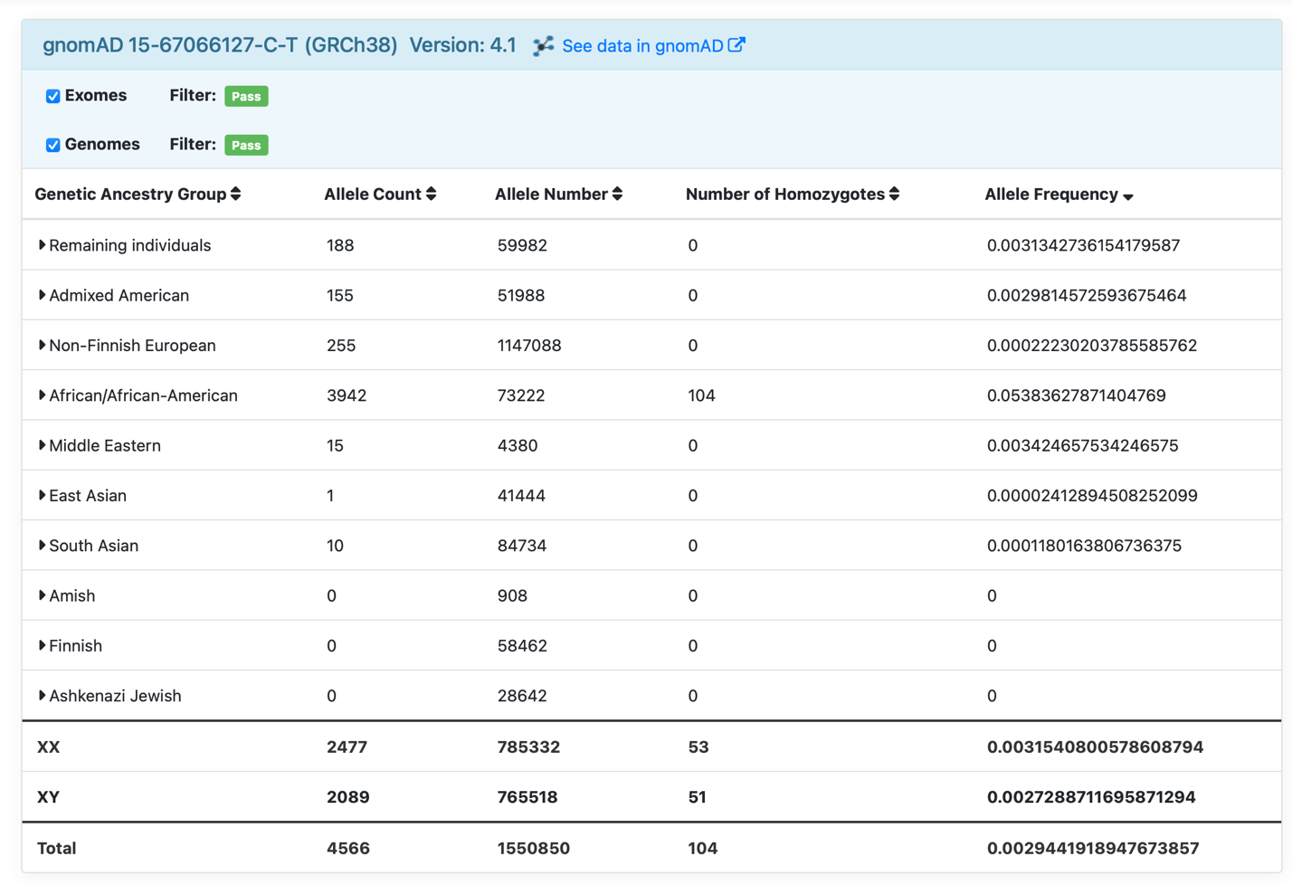

PM3
Use AI to check if in trans previously reported (clinvar)

PP1
Use AI to check if segregation previously reported (clinvar)
PP2
Get the gnomad zscore
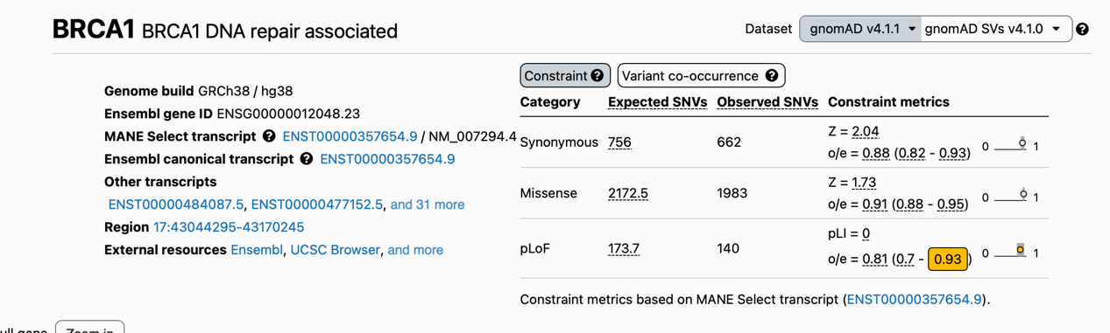
PP3, BP4:
Show the predictors, and follow below thresholds
